Biography 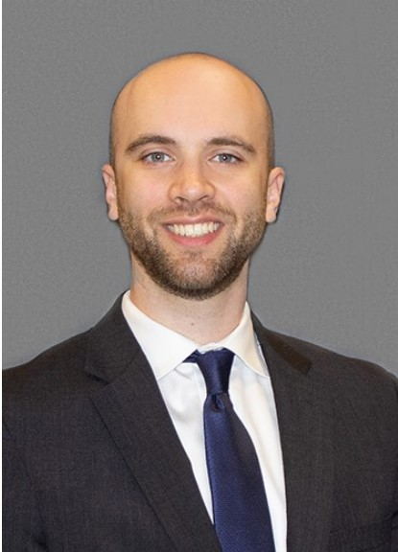
Dr. Joseph Conway is a fourth-year neurology resident, and chief resident for the Adult Neurology residency program at CCF. He completed his intern year at CCF, and his medical degree at Saint Louis University School of Medicine. He will complete a one-year fellowship in neuromuscular medicine at CCF. In addition to caring for patients with a variety of neuromuscular disorders, his other career interests include providing mentorship and coaching to students and residents as a medical educator. Outside of work, Dr. Conway enjoys spending time with his wife and dog, attending live music concerts, and exploring local coffee shops in search of the perfect cortado.

